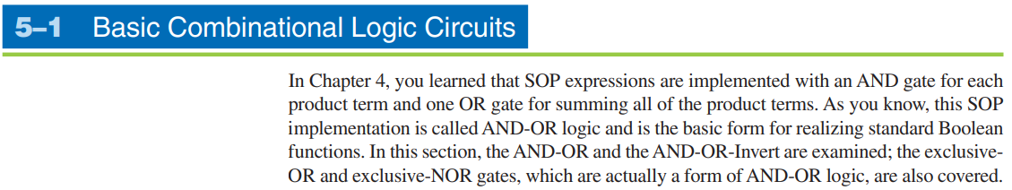

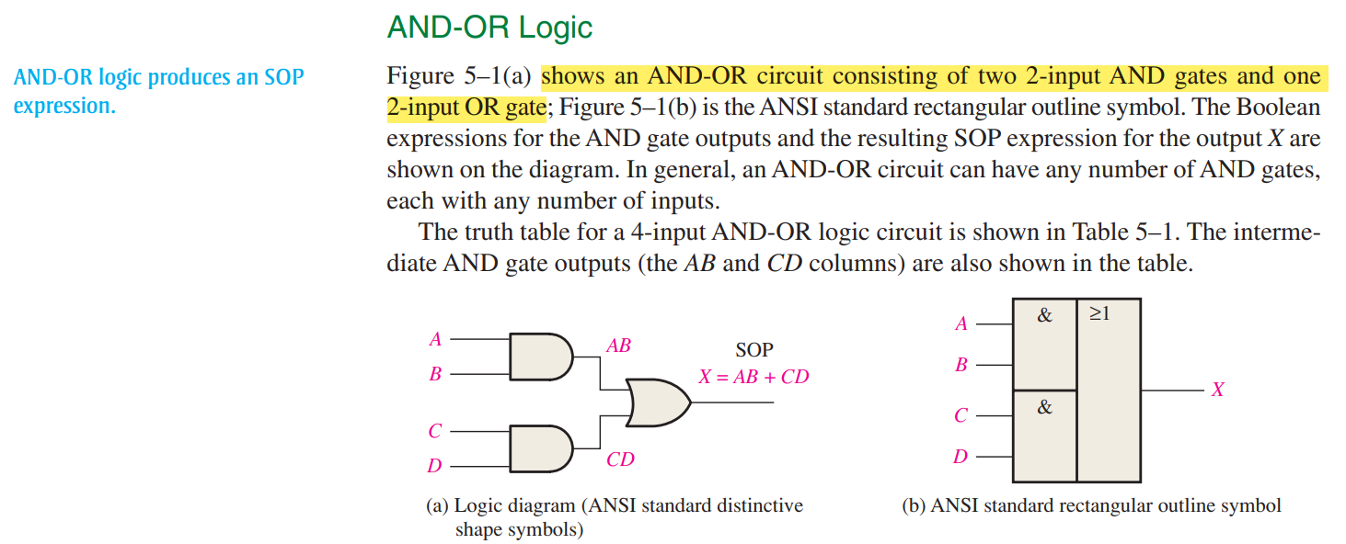



**Circuit Design Steps:**

1. Make truth table.
2. Write SOP
3. K-map Equation
4. Circuit Design

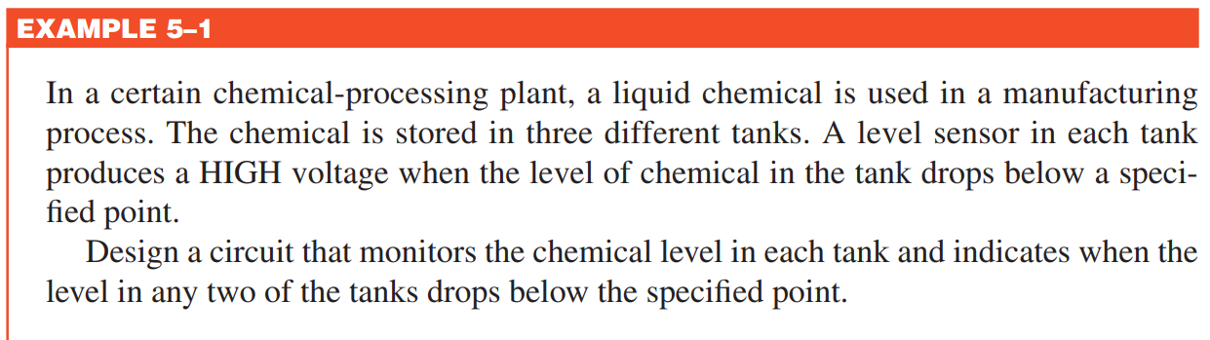

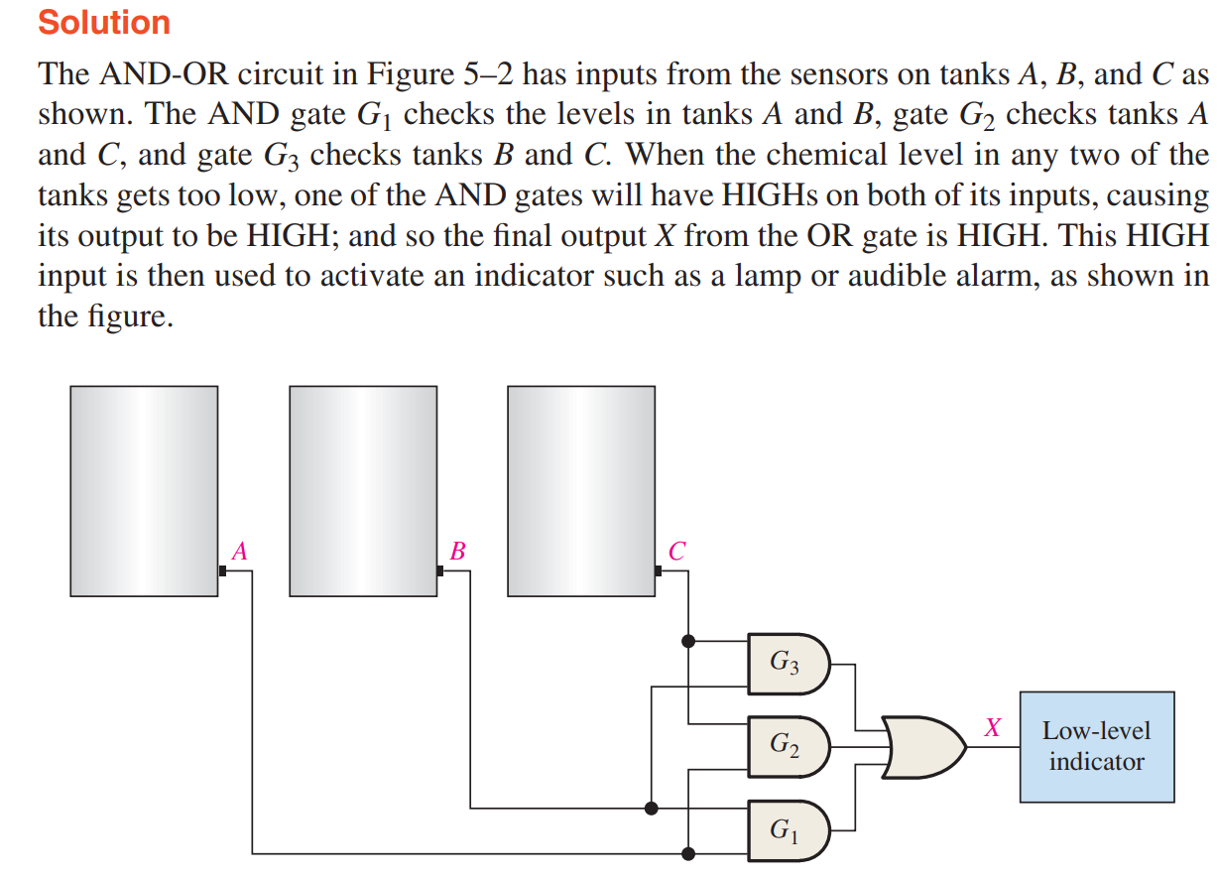

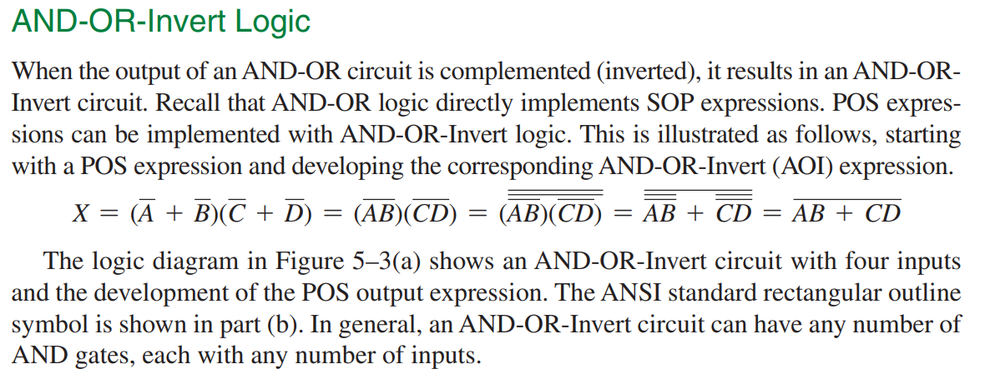

We must use a NOT gate at the end of a circuit diagram when using POS, because we make equation by looking at 0 output in the truth table, so by putting a NOT gate at the end makes it back in 1 output.



